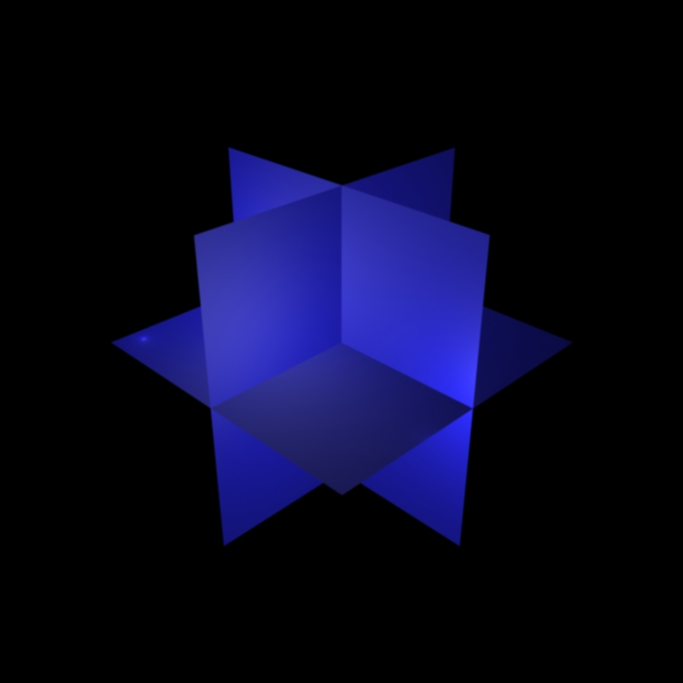
xy
xz
yz
z
x
y
Designed with 3DS MAX 5

