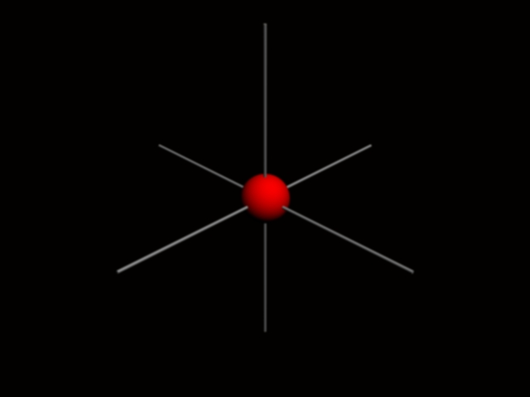
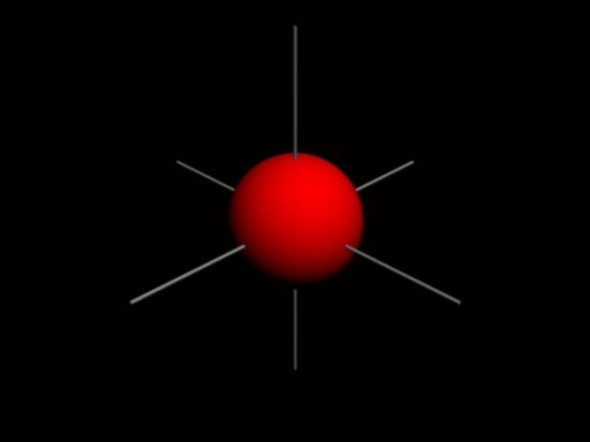
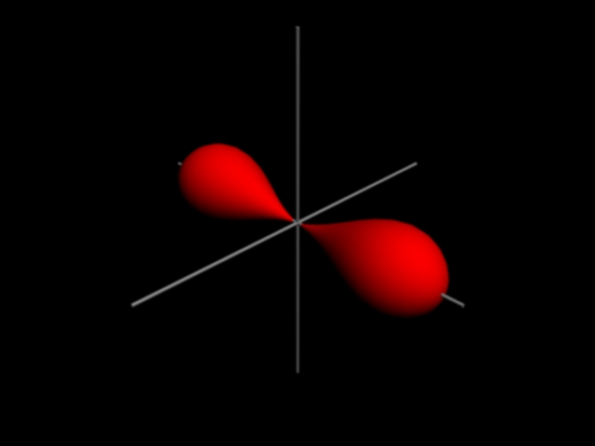

$ψ_{\text{1s}}=\frac{1}{\sqrt{π}}{\left(\frac{Z}{a_{0}}\right)}^{32}e^{−\text{Zr}a_{0}}$$ψ_{\text{2s}}=\frac{1}{4\sqrt{\text{2π}}}{\left(\frac{Z}{a_{0}}\right)}^{32}\left(\text{2-}\frac{\text{Zr}}{a_{0}}\right)e^{−\text{Zr}{\text{2a}}_{0}}$$ψ_{{\text{2p}}_{x}}=\frac{1}{4\sqrt{\text{2π}}}{\left(\frac{Z}{a_{0}}\right)}^{52}{\text{r e}}^{−\text{Zr}{\text{2a}}_{0}}\text{Sin}θ\text{Cos}θ$

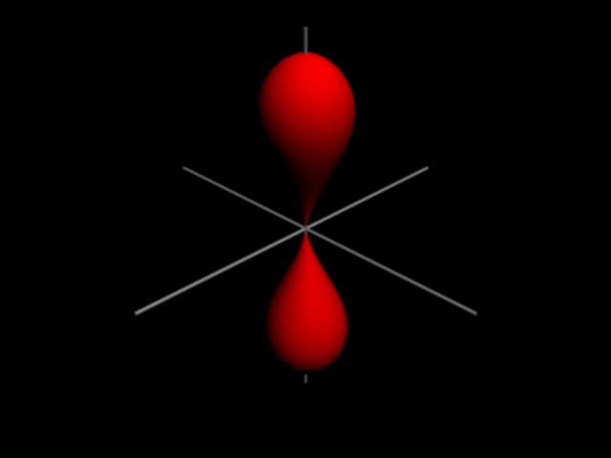
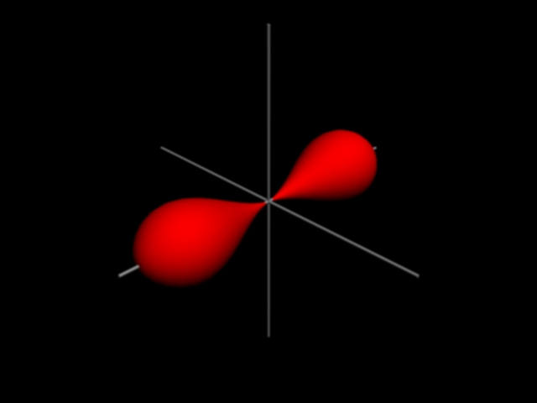

$ψ_{{\text{2p}}_{z}}=\frac{1}{4\sqrt{\text{2π}}}{\left(\frac{Z}{a_{0}}\right)}^{52}{\text{r e}}^{−\text{Zr}{\text{2a}}_{0}}\text{Cos}θ$
$ψ_{{\text{2p}}_{y}}=\frac{1}{4\sqrt{\text{2π}}}{\left(\frac{Z}{a_{0}}\right)}^{52}{\text{r e}}^{−\text{Zr}{\text{2a}}_{0}}\text{Sin}θ\text{Cos}φ$

$ψ_{{\text{3p}}_{x}}=\frac{\sqrt{2}}{\text{81}\sqrt{π}}{\left(\frac{Z}{a_{0}}\right)}^{52}\left(\text{6-}\frac{\text{Zr}}{a_{0}}\right){\text{ r e}}^{−\text{Zr}{\text{3a}}_{0}}\text{Sin}θ\text{Cos}φ$
$ψ_{\text{3s}}=\frac{1}{\text{81}\sqrt{\text{3π}}}{\left(\frac{Z}{a_{0}}\right)}^{32}\left(\text{27-18}\frac{\text{Zr}}{a_{0}}+2\frac{Z^{2}r^{2}}{a_{0^{2}}}\right){\text{ e}}^{−\text{Zr}{\text{3a}}_{0}}$

$ψ_{{\text{3p}}_{y}}=\frac{\sqrt{2}}{\text{81}\sqrt{π}}{\left(\frac{Z}{a_{0}}\right)}^{52}\left(\text{6-}\frac{\text{Zr}}{a_{0}}\right){\text{ r e}}^{−\text{Zr}{\text{3a}}_{0}}\text{Sin}θ\text{Sin}φ$$ψ_{{\text{3p}}_{z}}=\frac{\sqrt{2}}{\text{81}\sqrt{π}}{\left(\frac{Z}{a_{0}}\right)}^{52}\left(\text{6-}\frac{\text{Zr}}{a_{0}}\right){\text{ r e}}^{−\text{Zr}{\text{3a}}_{0}}\text{Cos}θ$

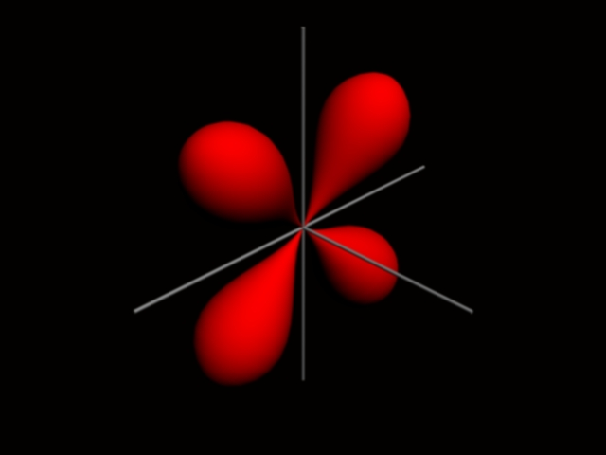
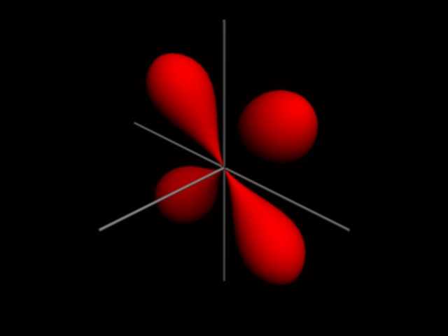

M.Hilmi Eren Ege Kimya Öğrencisi Mart 2004 www.geocities.com/mhilmieren

$ψ_{{\text{3d}}_{\text{yz}}}=\frac{\sqrt{2}}{\text{81}\sqrt{π}}{\left(\frac{Z}{a_{0}}\right)}^{72}r^{2}{\text{ e}}^{−\text{Zr}{\text{3a}}_{0}}\text{Sin}θ\text{Cos}θ\text{Sin}φ$
$ψ_{{\text{3d}}_{\text{xz}}}=\frac{\sqrt{2}}{\text{81}\sqrt{π}}{\left(\frac{Z}{a_{0}}\right)}^{72}r^{2}{\text{ e}}^{−\text{Zr}{\text{3a}}_{0}}\text{Sin}θ\text{Cos}θ\text{Cos}φ$

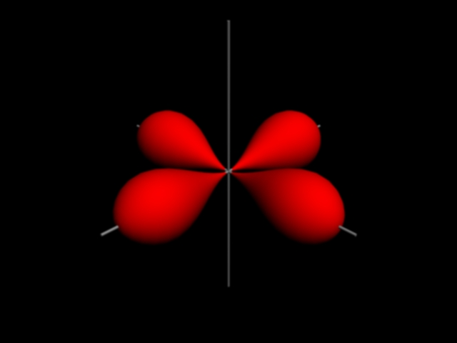
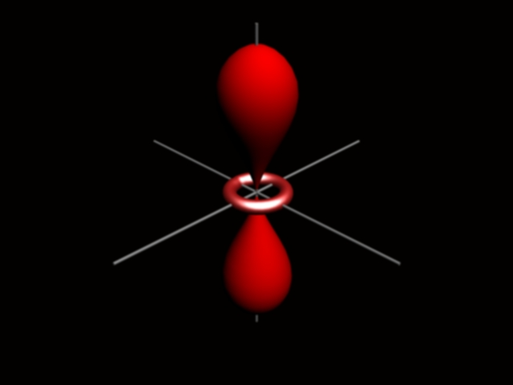

$ψ_{{\text{3d}}_{z^{2}}}=\frac{1}{\text{81}\sqrt{\text{6π}}}{\left(\frac{Z}{a_{0}}\right)}^{72}r^{2}{\text{ e}}^{−\text{Zr}{\text{3a}}_{0}}({\text{3Cos}}^{2}θ−1)$
$ψ_{{\text{3d}}_{x^{2}y^{2}}}=\frac{1}{\text{81}\sqrt{\text{2π}}}{\left(\frac{Z}{a_{0}}\right)}^{72}r^{2}{\text{ e}}^{−\text{Zr}{\text{3a}}_{0}}{\text{Sin}}^{2}\text{θCos2}φ$
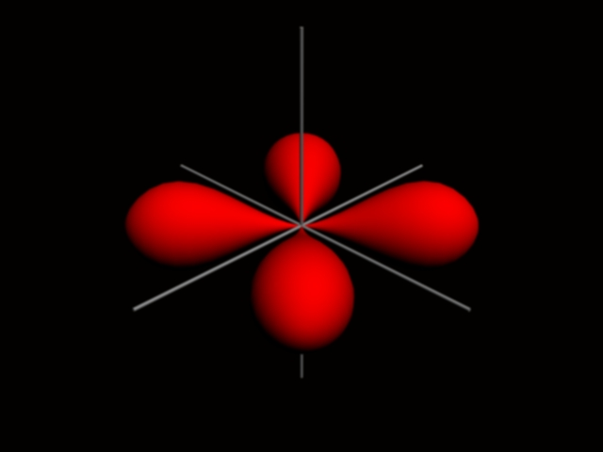
$ψ_{{\text{3d}}_{\text{xy}}}=\frac{1}{\text{81}\sqrt{\text{2π}}}{\left(\frac{Z}{a_{0}}\right)}^{72}r^{2}{\text{ e}}^{−\text{Zr}{\text{3a}}_{0}}{\text{Sin}}^{2}\text{θSin2}φ$

